# **CHAPTER 1: INTRODUCTION**

**1.1 OVERVIEW**

The rapid growth of electric vehicles (EVs) has intensified the demand for efficient, reliable, and fast-charging infrastructure. Among various charging standards, Level 3 DC fast charging stands out due to its ability to significantly reduce charging time, making it more suitable for commercial and high-usage scenarios. However, integrating such high-power systems into the grid poses considerable challenges related to energy balancing, load management, and grid stability—especially when operating within a microgrid composed of multiple, variable power sources.

A microgrid typically consists of distributed generation (DG) units such as solar panels, wind turbines, and diesel generators, along with battery energy storage systems (BESS). Managing energy from these diverse sources requires an advanced Energy Management System (EMS) that can monitor, control, and optimize power flows in real-time. An effective EMS not only ensures continuous power availability and economic operation but also supports seamless integration of fast EV charging stations.

In addition to efficient energy distribution, fault detection is a critical aspect of microgrid reliability. Faults in power electronic systems, batteries, and DG units can lead to system failures or unsafe operating conditions. This project utilizes Discrete Wavelet Transform (DWT) and Discrete-Time Fourier Transform (DTFT) techniques to detect and analyze faults within the microgrid and battery systems. These signal processing methods enable high-resolution analysis of voltage and current signals, allowing for early and accurate fault identification.

This project aims to develop a comprehensive model that integrates Level 3 DC charging with a smart EMS and advanced fault detection mechanisms. The system is modeled and simulated in MATLAB/Simulink, evaluating its performance under various operational scenarios. The outcome contributes to the advancement of intelligent microgrid systems that can support fast EV charging while maintaining stability, safety, and efficiency in energy management.

**1.2 LITERATURE REVIEW**

Research paper [1] addresses the design and control aspects of a three-phase active rectifier utilizing an LCL filter. The primary objective of the paper is likely to present a comprehensive study on the design and control strategies of a three-phase active rectifier incorporating an LCL filter. Active rectifiers are power electronic devices that convert AC power to DC power and are commonly used in various applications, including electric vehicle battery chargers, renewable energy systems and industrial drives. Details on the design considerations for the LCL filter, which is commonly used in power electronic converters to attenuate harmonic distortion and improve the performance of the system are provided in the following paper.Comparisons with other control strategies or filter designs are also presented to highlight the advantages of the proposed approach.

A control strategy for generating a switching sequence for the three phase rectifier switches is introduced in research paper [2]. In the model, a simple ‘p-q’ theory based voltage oriented control algorithm is used which is reported in following paper. In order to keep a constant DC link voltage under dynamic load conditions, rectifier control will be performed with a synchronously rotating d-q frame in order to independently control load current d and q axis components and also active/reactive powers.

This paper [3] focused on Dual Active Bridge Converter for Solid State Transformer application by Single-Phase Shift Control Technique. In this paper we present the classification of Isolated Bidirectional DC-DC converter topology in accordance with the number of different topologies used, and study the circuit configuration of the 1-phase H-bridge DAB DC-DC converter. It presents the Single Phase Shift (SPS) technique, which is widely used DAB control scheme, and shows simulation results that illustrate the improvement of the steady-state performance with the SPS control strategy with a PI controller.

**1.3 PROBLEM DEFINITION**

We have been heavily dependent on combustion engines for transportation since a long time, but these engines use petrol and diesel to power the engine which leads to depletion of these limited sources of energy and also causes environmental pollution. Since these fuels are present in a limited quantity in nature it is necessary to shift our wants to a better alternative source of energy. This leads us to shift towards alternative forms of energy to power the vehicles. As most of us shift our focus towards electric vehicles, one of the major problems encountered in this regard is charging the battery. Conventional chargers take a long time to charge the battery and hence it is not feasible to use these vehicles for longer ranges. To tackle these challenges, this part of the project aims to reduce the charging time of the battery by developing a DAB incorporated SST based electric vehicle fast charger for fast charging of the battery in order to reduce the charging time.

**CHAPTER 2: Electric Vehicle Charging Technology**

**2.1 THEORY**

EV charging stations are basically refueling stations for electric vehicles that are placed at strategic locations to ensure they are available to be used whenever necessary. The charging point is connected to the charging panel through a cable and the panel contains the user interface which is accessed by the users of the charging station. Depending on the grid, various parameters such as the voltage and outlet configuration determine the power output of the charger.  
Of the various known standards of electric vehicle charging, type 1 and type 2 are the most known types of charging where as type 3 DC fast charging is a relatively newer technology.

**2.1.1 Charging Modes**

**2.1.1.a Level 1 charging**Level 1 (L1) chargers are especially useful for people who have access to charging points at work or school, allowing them to top up their electric vehicles (EVs) throughout the day.

However, since L1 charging is quite slow, EV drivers often refer to it as a emergency charger rather than a primary charging solution. L1 chargers use standard household outlets, which run at 120V and deliver up to 16 amps of current. This setup provides a maximum power output of about 1.9 kW, meaning it can take anywhere from 8 to 16 hours to fully charge a battery, depending on its size. To connect the EV to the charging station, an SAE J1772 connector is typically used. While L1 charging isn’t ideal for long commutes or road trips, it’s a convenient option for overnight charging at home or for keeping your battery topped up when parked for long hours at work or school.

**2.1.1.b Level 2 charging**Level 2 (L2) charging stations are the most prevalent choice for both public and residential EV charging which offer a much faster alternative to Level 1 chargers. To meet L2 requirements, these stations use a 240V single-phase power supply with a maximum current of 40A for home and commercial setups. Public charging stations, on the other hand, often rely on a three-phase 400V AC power supply with up to 80A of current for higher power output and much higher efficiency.

L2 chargers are found in a variety of locations, from parking and business entrances to schools and colleges, where employees and students can conveniently charge their vehicles. These stations are compatible with all EVs that use the industry-standard J-plug, also known as the SAE J1772 connector.

The maximum charging power of L2 chargers is around 12 kW. An L2 charger can add roughly 100 miles of range in about seventeen to eighteen hours, making it a great option for daily charging. Plus, L2 charging systems come with built-in safety options for overcurrent and overvoltage protection, ensuring safe and reliable operation.

**2.1.1.c Level 3 DC fast charging**

Level 3(L3) is the fastest charging method for electric vehicles. This type of charger is typically used in public and commercial areas where faster charging time is the most preferred. Due to the rapid fast charging speed, vehicles can be recharged quickly in high traffic and perennially busy areas.

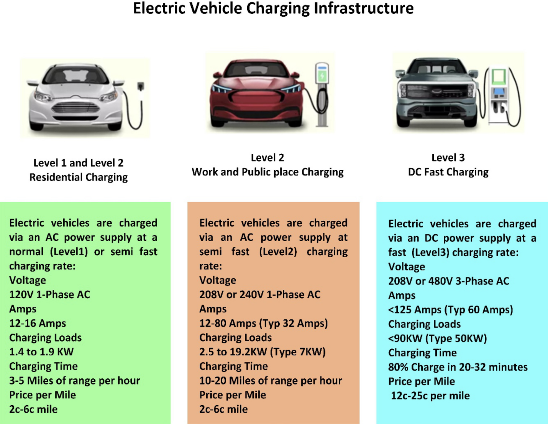In addition, L3 chargers do not comply with industry standards and are not universally compatible. By using DC charging technology, these stations are designed to provide a similar user experience to that of traditional filling stations. The charge time for a battery from 0 to 80% is usually 15 to 20 min with DC fast charging. All 20% of the remaining battery will always be charged in slow mode, regardless of the charging level. DC power is delivered to the electric vehicle by converting AC power from an off-board charger. Charging voltages for L3 typically range from 200 to 600 V, and power outpots range from 36 to 240 kW. Most DC power output charging stations are located in malls, government buildings, movie theaters, [airports](https://www.sciencedirect.com/topics/engineering/airfield), and refueling stations. DC charger connectors having the SAE/IEC J1772/IEC 62,196–3 standard are recommended by SAE and IEC. Level 3 DC fast-charging stations have a significant drawback due to their high installation costs.



**2.2 Battery**

Electric vehicles (EVs) commonly use lithium-ion batteries because of their high energy density, long cycle life, and efficient performance. These batteries serve as the main energy storage system, powering the electric motor and onboard electronics. Most EV battery packs operate at voltages between 300 and 400 volts, though some high-performance models use 800-volt systems for faster charging and improved efficiency. Current ratings can vary significantly based on the vehicle’s design, typically ranging from 100 to 400 amps. The combination of high voltage and current enables EVs to deliver strong acceleration, long driving ranges,and support for level 3 DC fast charging applications or G2V operations.

**2.3 Three Phase Rectifier**

Incorporating a three-phase rectifier as the first stage of the project is a crucial aspect of Level 3 DC fast charger design. This rectifier is responsible for converting the AC input from the grid into DC, which can be further transformed and controlled to charge electric vehicle batteries efficiently.

AC-DC converters with regulated outputs are commonly used as the front-end stage for feeding DC-DC converters. In high-power applications, using three-phase rectifiers is beneficial, especially when combined with active power factor correction techniques to improve efficiency and ensure better alignment with the input AC supply.

The three-phase rectifier plays an important role in the overall design, and its performance significantly impacts the efficiency and effectiveness of the Level 3 DC fast charger. Several key functions which highlight the importance of this initial stage are as follows:

* **AC to DC Conversion:** The three-phase rectifier is responsible for the conversion of the grid's AC power into DC power, a critical step in the charging process. This conversion is essential as electric vehicles primarily rely on DC power for charging their batteries.
* **Power Factor Correction:** Efficient power factor correction is vital in ensuring that the charger operates harmoniously with the grid. The three-phase rectifier is instrumental in this regard, helping to achieve a unity power factor or close to it. This not only minimizes energy losses but also reduces the impact of the charger on the grid's power quality.
* **Ripple Reduction:** The rectifier stage also contributes to reducing ripple and harmonics in the DC output voltage. This is essential for the safe and efficient charging of EV batteries, as excessive ripple can lead to heat generation and potential damage to the batteries.
* **Grid Compatibility:** The rectifier facilitates smooth interaction between the charger and the grid, ensuring that the charger complies with grid standards and with power quality issues like minimizing the disruptions, and avoids voltage sags or swells.

**2.4 Role of an input filter:**

We have used an LCL (Inductor-Capacitor-Inductor) filter as an input filter before the rectification stage to improve overall performance of the system.

Here are some key reasons for incorporating LCL filter:

1. **Harmonic Mitigation:** One of the primary reasons for using an input LCL filter is to reduce and mitigate harmonics in the current waveform. Rectifiers operating without filtering can generate harmonics in the input current due to the non-linear nature of the rectification process. These harmonics can have detrimental effects on the electrical grid, potentially causing power quality issues and compliance problems with grid regulations. The LCL filter is designed to attenuate these harmonics, resulting in a cleaner and more sinusoidal input current.
2. **Damping of voltage spikes:** Voltage spikes, inherent to switching transitions during rectification, can pose a threat to the system and its components. The LCL filter's inductor component plays a crucial role in damping these voltage spikes, ensuring system protection and longevity.

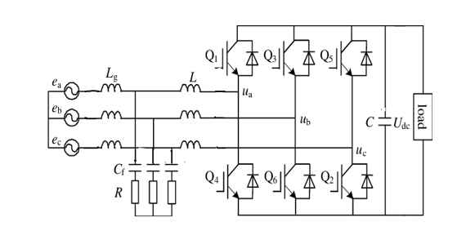

**2.5 Control Technique:**

We implemented a multi-stage transformation process for generating pulses to drive the IGBTs used in the rectifier.

**Step1: ABC to αβ0 Transformation**  
The first stage involves converting the three-phase signals (ABC) into the αβ reference frame using the Clarke Transformation. This step is essential for analyzing and controlling three-phase systems such as rectifiers.

The Clarke Transform block translates the time-domain signals from the ABC frame to a stationary αβ0 frame. A power-invariant form of the transform is used to ensure that the active and reactive power in the αβ0 frame matches that of the original ABC system. In a balanced system, the zero-sequence component becomes zero.

|  |  |
| --- | --- |
| abc.png  **Fig 2.5.1. Direction of the magnetic axes of the stator windings in the abc reference frame and the stationary αβ0 reference frame.** | alphabetaaxes.png  **Fig 2.5.2. *α*, *β*, and zero components in the stationary reference frame.** |

The primary objectives of this transformation are:

* **Simplifying Analysis:** The ABC to αβ transformation simplifies the mathematical analysis of the three-phase variables by projecting them onto a two-dimensional plane. This simplification eases the design and control of the rectifier.
* **Decoupling Variables:** By transforming to the αβ frame, the direct (α) and quadrature (β) components of the three-phase system are separated. This decoupling allows for independent control of real power (P) and reactive power (Q).

**Step 2: αβ to DQ Transformation**After completing the ABC to αβ transformation, the next step is to convert the αβ components into the DQ reference frame. In this frame, D represents the direct axis and Q represents the quadrature axis. This transformation is carried out using an Alpha-Beta-Zero to DQ0 block.

The Alpha-Beta-Zero to DQ0 block transforms the αβ0 components from the stationary Clarke reference frame into DQ0 components in the rotating Park reference frame. This conversion simplifies control and analysis of AC systems by aligning the reference frame with the rotating vector of the system, making it easier to manage variables like torque and flux.

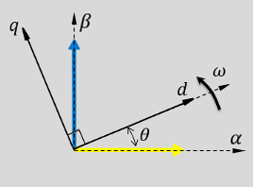

**Fig 2.5.3. *α-β* axes components in an *αβ* reference frame and rotating *dq* reference frame**

**D-axis Current Control**: The D-axis is aligned with the direct current (DC) component, allowing for precise control of the DC link voltage. This is crucial for regulating the output voltage and ensuring a constant, well-controlled charging voltage for electric vehicles.

**Q-axis Current Control**: The Q-axis control is useful for achieving power factor correction. By manipulating the Q-axis current, the rectifier can minimize reactive power and improve the overall power factor of the system.

**Step 3: DQ to ABC Transformation:**

After performing the PI control on VD, VQ and ID, IQ in the DQ frame, the transformed signals are converted back to the ABC reference frame to generate the PWM signals. This conversion is necessary for practical implementation, as the PWM modulation signals must be in the three-phase ABC format

.The Inverse Park Transform block converts the time-domain direct, quadrature, and zero components in a rotating reference frame to the components of a three-phase system in an *ABC* reference frame. The block can preserve the active and reactive powers with the powers of the system in the rotating reference frame by implementing an invariant version of the Park transform. For a balanced system, the zero component is equal to zero.

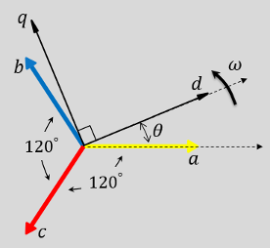

**Fig 1.5.4. Direction of the magnetic axes of the stator windings in an *abc* reference frame and a rotating *d*-*q* reference**

The DQ to ABC transformation serves the following purposes:

**Practical Implementation:** Many power electronic devices, including the switching elements used in rectifiers, work with three-phase signals. The transformation ensures compatibility between the control signals and the physical hardware.

**PWM Signal Generation:** The transformed DQ signals are used to generate the PWM signals, which determine the switching of the rectifier's semiconductor devices (e.g., IGBTs or MOSFETs).

**2.6 Calculation of Output DC voltage of the Rectifier**

The formula to find output DC voltage of 3 phase full controlled rectifier is given by,

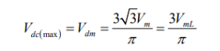

Here, the value of Vrms is 415V line-line

Hence, value of Vdc was found out to be 586 V.

**2.6.1 Waveform of 3 phase Rectifier output:**

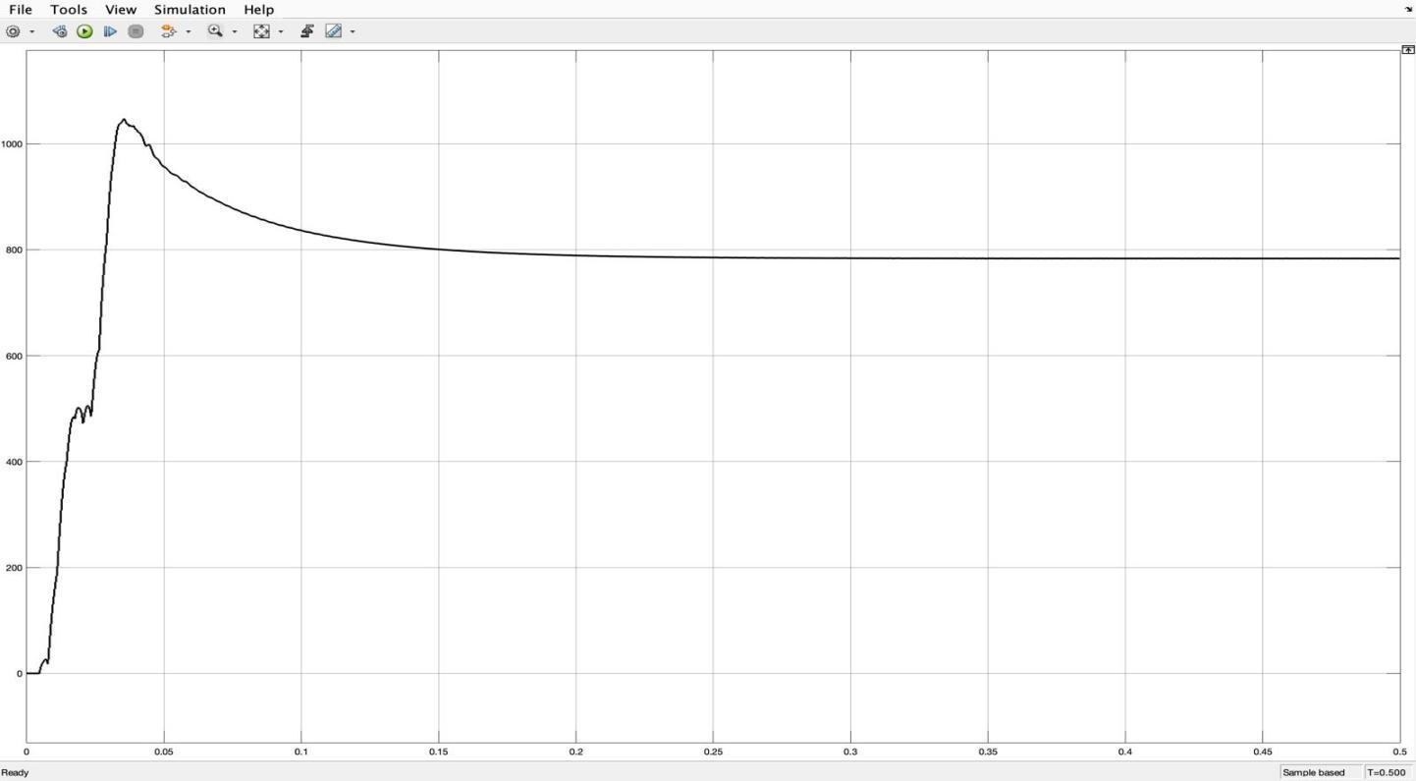

**Fig.: DC output of 3 phase Rectifier**

**2.7 DUAL ACTIVE BRIDGE CONVERTER**

In the 1990s, the Dual Active Bridge (DAB) converter was introduced to support bidirectional power flow in high-power applications. However, under increased current stress, device costs can rise, and efficiency may drop, potentially leading to device damage. Despite this, DAB converters effectively manage current and enable controlled power flow on both sides of the transformer. A high-frequency transformer is used to provide galvanic isolation between the two DC-DC converter stages.

In fast charging systems, particularly Level 3 DC fast chargers for electric vehicles, high-power DC output is essential to significantly reduce charging time compared to Level 2 chargers. To meet these power requirements, the charger must efficiently convert grid-supplied AC power into regulated DC power for the vehicle battery.

The DAB topology plays a key role in this design, offering several advantages such as soft-switching capabilities, fewer power devices, and high overall efficiency, making it well-suited for modern high-power EV charging systems.

**Features:**

* Single-phase-shift, DAB
* Soft switching
* Bidirectional power flow
* Isolated voltage and current sensing
* PWM switching frequency of 50 kHz
* Transformer size
* Galvanic Isolation
* Modular Design

The DC/DC converter used in EV charging systems must be capable of handling high power levels to meet demanding performance requirements. Additionally, modularity is essential, allowing individual power stage units to be connected in parallel. This modular approach enables the system's output power to be scaled up to meet the varying demands set by DC charging station standards.

Modern charging infrastructure is increasingly adopting converters that support bidirectional power flow. Emerging technologies like Vehicle-to-Grid (V2G) allow energy to flow not only from the grid to the vehicle but also in reverse—from the vehicle’s battery back to the grid. Bidirectional DC/DC converters make this possible by enabling battery charging during forward operation and supplying power back to the grid during reverse operation. This functionality can play a critical role in grid stabilization during peak demand periods.

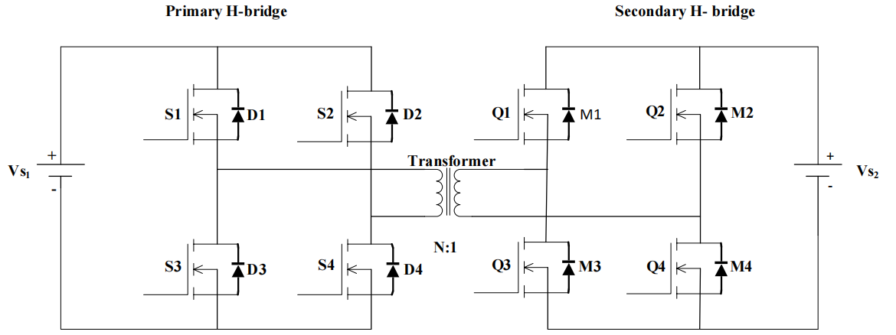A 1-phase H-bridge DAB Dc-Dc converter is shown. There are two legs in each H-bridge. On the LV side, there are four switches with four antiparallel diodes. Diodes D1, D2 & D3, D4 have been connected in antiparallel across the switches S1, S2 & S3, S4. Similarly, diodes M1, M2 & M3, M4 have been connected in antiparallel across the switches Q1, Q2 & Q3, Q4. A high-frequency transformer is connected between Two H- Bridges. Input signal Vs 1 is applied through the primary H- Bridge. At time t1 switches S1 & S2 are Turn-on and after 50% delay switches Q1& Q4 are turned on. At the same time t2 switches S2 & S3 are ON. After providing phase shift, switches Q2 & Q3 are on.

**Fig 3 Circuit configuration of DAB dc-dc converter**

**2.7.1 Dual-Active Bridge - Design Considerations**

A number of factors are critical in the design of the power stage of a dual-active bridge. The most important factors are the selection of leakage inductor, desired phase shift of operation, output capacitor rating, switching frequency of operation, selection of SiC MOSFETs, transformer, and intended ZVS range of operation. The selection of the leakage inductor has a direct effect on the maximum power transferred, which in turn affects the phase shift of operation of the converter at the intended power level. Each of these factors are discussed in detail in the following sections:

#### 2.7.1.1 Leakage Inductor

The most important design parameter is the selection of leakage inductor. The power transfer relation of the dual-active bridge is given by

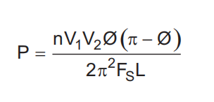

Figure 2-1-3-1 shows the inductor current waveform. The value of current at points i1 and i2 can be derived from this waveform.

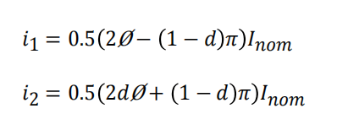

#### 2.7.1.2 Phase Shift

The phase shift of the converter is dependent on the value leakage inductor. The phase shift for required power transfer is given by

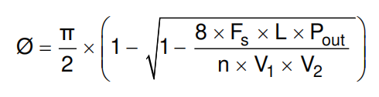

for a small value of inductance, a maximum power transfer at a small value of phase shift is obtained. To have fine control over power transferred, fine high resolution steps in which the phase can be varied must be obtained. Alternatively, a larger inductor can obtain maximum power transfer at a high value of phase shift for better control.

#### 2.7.1.3 Effect of Inductance on Current

In the previous section, it is noted that a high value of leakage inductance can contribute to soft switching up to a very low power level and hence leads to better switching performance. Alternatively, increasing the leakage inductance leads to increased RMS currents in the primary and secondary of the transformer, switch currents, and ripple currents in the capacitor. Figure 1-1-3-2 shows that as the value of leakage inductance increases, the RMS currents in the transformer and switches increase, leading to more conduction losses. Thus, there exists a tradeoff between an optimal value of leakage inductance to affect ZVS and minimizing conduction losses.

#### 2.7.1.4 Switching Frequency

Switching frequency is another important design parameter which affects the efficiency and power density of a power converter. The input and the output voltage levels primarily determine the type of switches used in the power stage. Usage of SiC MOSFETs in the power stage drives the switching frequencies to very high levels. Operating at higher switching frequencies enables reduced size of magnetics which help in improved thermal solution, thereby improving power density of the converter. Therefore, selection of switching frequency is primarily a tradeoff between the allowable heat sink solution and transformer size for a given efficiency target.

Secondly, if the output capacitance (Ecoss) of MOSFET is very high, selection of high switching frequency leads to high switching losses at light load and hampers efficiency. Selection of switching frequency also affects the control loop bandwidth implementation. Considering all of these parameters, 50 kHz was used as the switching frequency for this application

## **2.8 Waveforms**